## PRACTICAL THIRTEEN: THREE-WAY AND FOUR-WAY ANOVA WITH SPSS

1. Generate a LS problem and corresponding data.
2. Set the hypothesis for the problem.
3. Give a step and step procedure for running the analysis with SPSS.
4. Give the SPSS data structure for the analysis and run the analysis.
5. Give the decision rule and conclusion based on the outcome of your analysis
6. Generate a GLS problem and corresponding data.
7. Set the hypothesis analysis for the problem.
8. Give a step by step procedure for running the analysis with SPSS
9. Give the SPSS data structure for the analysis and run the analysis
10. Give the decision rule and conclusion based on the outcome of your analysis.

SOLUTION

A research to examine a new class of drug that has the potential to lower cholesterol levels and thus helps against heart attack on both male and female.

Null Hypothesis, Ho: **The new class of drugs might affect male and female differently**.

Alternative Hypothesis, H1: **The new class of drugs might not affect male and female differently**.

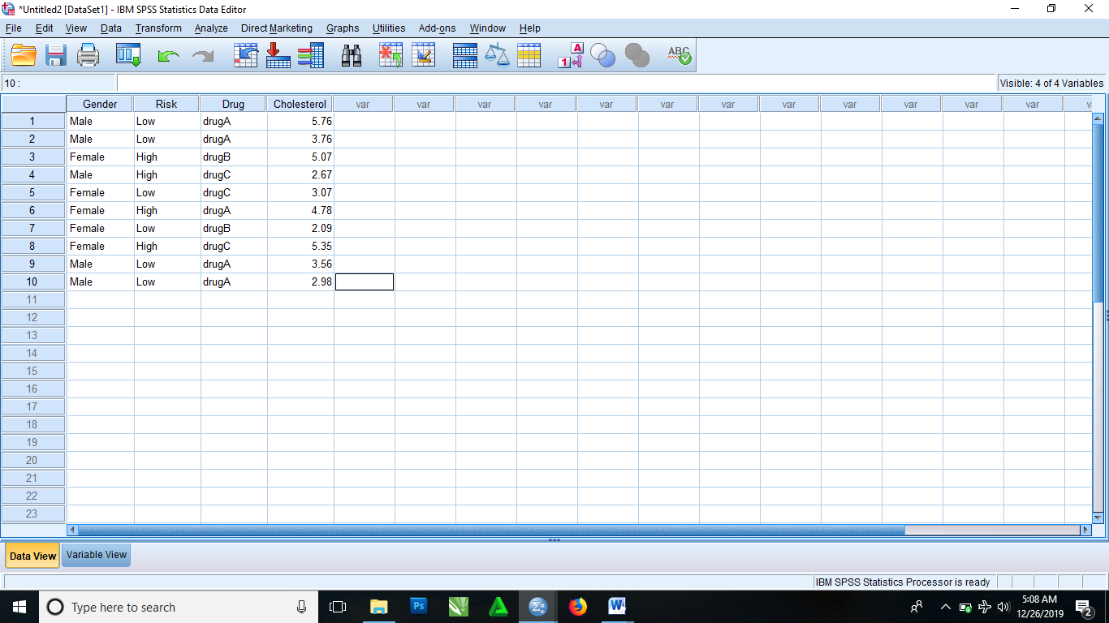

After inputting your data into SPSS and doing all necessary editing in the variable view. Then,

* From the menus, select

Analyze > General Linear Model > Univariate

* It then brings you to Univariate dialog box where you select variables from list of variables in the left box. Then click on Cholesterol, drag and drop in the Dependent variable box. Click on Gender, Risk and Drug, drag and drop them in the Fixed Factor(s) box.
* Click on Options
* It then brings you to a dialog box. In this dialog box there is list of variables in the Factor(s) and Factor interactions box, then click and drag Gender*Risk*Drug

Then proceed to the Display dialog box then select Descriptive statistics and Homogeneity tests.

* Click Continue
* Click OK

|  |  |  |  |  |  |
| --- | --- | --- | --- | --- | --- |
| **Tests of Between-Subjects Effects** | | | | | |
| Dependent Variable: Cholesterol | | | | | |
| Source | Type III Sum of Squares | df | Mean Square | F | Sig. |
| Corrected Model | 9.776a | 6 | 1.629 | 1.114 | .505 |
| Intercept | 99.105 | 1 | 99.105 | 67.752 | .004 |
| Gender | 3.591 | 1 | 3.591 | 2.455 | .215 |
| Risk | 6.917 | 1 | 6.917 | 4.729 | .118 |
| Drug | .520 | 2 | .260 | .178 | .845 |
| Gender * Risk | .000 | 0 | . | . | . |
| Gender * Drug | .000 | 0 | . | . | . |
| Risk * Drug | .122 | 1 | .122 | .084 | .791 |
| Gender * Risk * Drug | .000 | 0 | . | . | . |
| Error | 4.388 | 3 | 1.463 |  |  |
| Total | 166.967 | 10 |  |  |  |
| Corrected Total | 14.164 | 9 |  |  |  |
| a. R Squared = .690 (Adjusted R Squared = .071) | | | | | |

|  |  |  |  |  |  |  |
| --- | --- | --- | --- | --- | --- | --- |
| **Gender * Risk * Drug** | | | | | | |
| Dependent Variable: Cholesterol | | | | | | |
| Gender | Risk | Drug | Mean | Std. Error | 95% Confidence Interval | |
| Lower Bound | Upper Bound |
| Female | High | drugA | 4.780 | 1.209 | .931 | 8.629 |
| drugB | 5.070 | 1.209 | 1.221 | 8.919 |
| drugC | 5.350 | 1.209 | 1.501 | 9.199 |
| Low | drugA | .a | . | . | . |
| drugB | 2.090 | 1.209 | -1.759 | 5.939 |
| drugC | 3.070 | 1.209 | -.779 | 6.919 |
| Male | High | drugA | .a | . | . | . |
| drugB | .a | . | . | . |
| drugC | 2.670 | 1.209 | -1.179 | 6.519 |
| Low | drugA | 4.015 | .605 | 2.090 | 5.940 |
| drugB | .a | . | . | . |
| drugC | .a | . | . | . |
| a. This level combination of factors is not observed, thus the corresponding population marginal mean is not estimable. | | | | | | |